IMPORTANT NOTICE
重要通知
留学生查询成绩方法
1、进入http://iso.snnu.edu.cn, 已有账户学生可登录，无账户学生请注册新账户登录
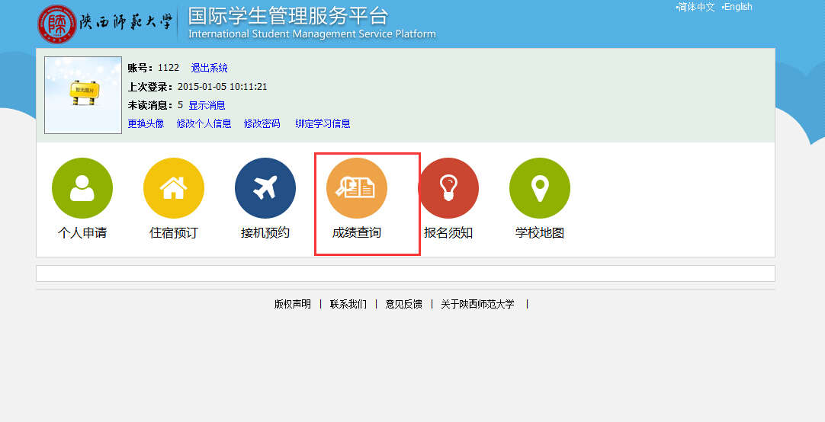
2、点击成绩查询

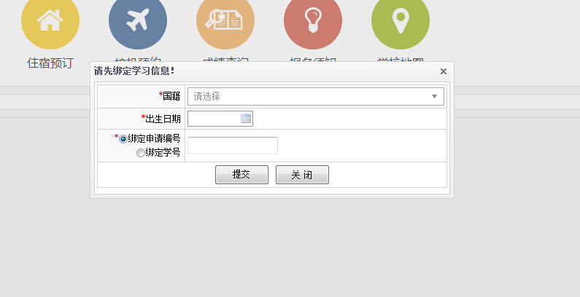
3、绑定个人账户请选择你的国籍，填写出生日期以及绑定你的申请编号或者学号（学号在你的学生证上的照片下面）
How to Check Your Grades Online
- Website: http://iso.snnu.edu.cn, log in if you have the account; if not, register a new account to log in
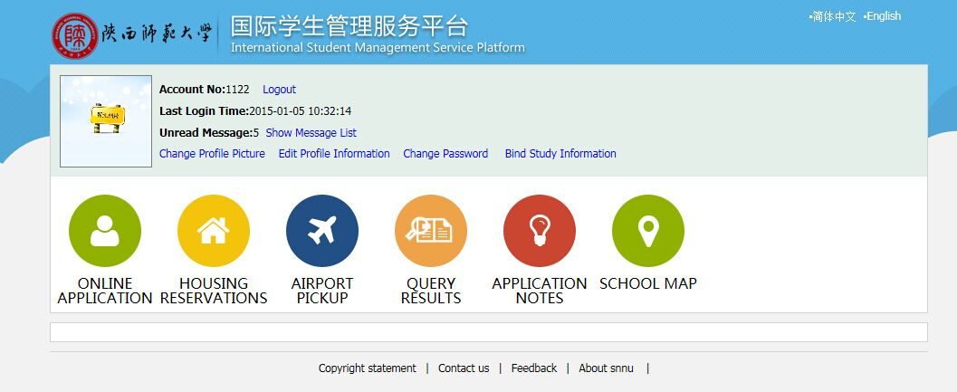
- Click Query Results
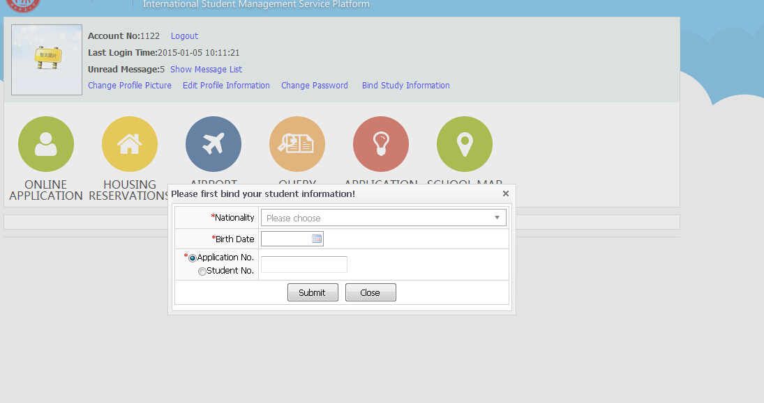
3. Bound your account

Select your nationality and birth date, and fill up your application no. or you student ID no. (You can find it on your student ID card, below your photo)

